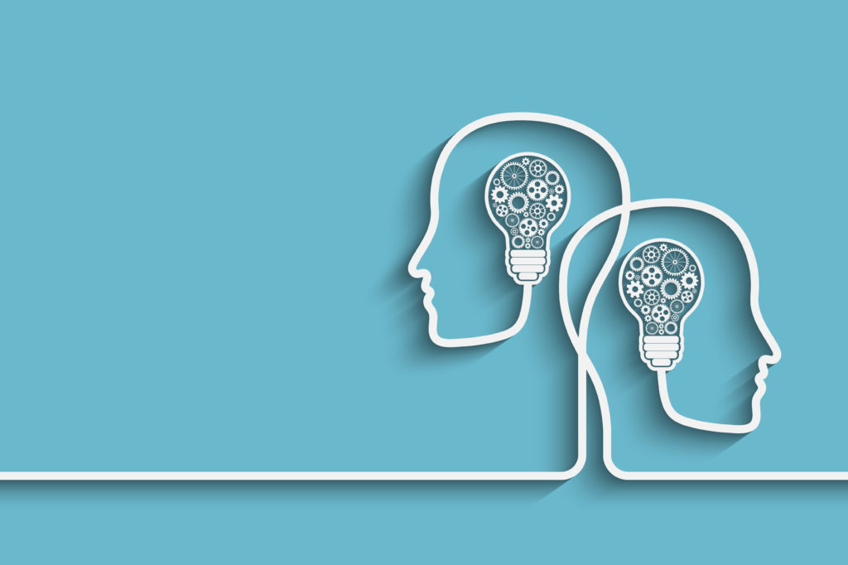

[Cognitive Development (Piaget’s Theory)]

Group Members:

* Bilal Shakeel 21K-4874
* Muhammad Tahir 21K-4503
* Muhammad Samamah 21K-3205
* Mujtaba Noondani 21K-3255

[Submitted to: Miss Shahtaj Shakir]

[Date: Monday, 14th November 2022]

# [Introduction (Who was Jean Piaget?)]

# Jean Piaget was a Swiss psychologist who was born on 9th August 1986. In his early life, he mainly was interested in zoology. His articles on albino sparrows and mollusks made him popular among European zoologists. However, he started to gain interest in Psychology. He first went to Zürich, where he studied under Carl Jung and Eugen Bleuler, and he then began two years of study at the Sorbonne in Paris in 1919

# Piaget's Theory of Cognitive Development

### [Background]

### Piaget worked at Binet Institute in the 1920s, where his work was to make French version of questions on English intelligence tests. He was curious to know why children gave wrong answers to questions that required logical thinking. He believed that this was so because the thinking process of adults and children is different. He went on to make few assumptions, which were:

### The quality of thinking differed between children and adults. Children think of the world in a different way.

### Children throughout their development stages accumulate their knowledge about the world. They do not require someone else to tell them about how the world works.

### Children’s reasoning is based on their point of view.

### Hence, Piaget started to study children from their birth to their development into a grown adult. He started from his three children, through both, naturalistic and controlled environment. He then made a development chart for all of them.

### [Piaget's four stages]

### Jean Piaget’s cognitive development theory includes four stages that children go through in their intellectual development. Child development is determined by biological maturation and social interaction. Thinking in each stage differs qualitatively with others.

### The stages are:

|  |  |  |
| --- | --- | --- |
| Stage | Age | Goal |
| Sensorimotor | Birth to 2 years | Object permanence |
| Preoperational | 2 to 7 years | Symbolic thought |
| Concrete operational | Ages 7 to 11 years | Logical thought |
| Formal Operational | Adolescence to adulthood | Scientific Reasoning |

### There can be individual differences that may occur due to stinted growth which is why some individuals might not reach any of the mentioned stages.

### Piaget's Theory of Cognitive Development - YouTube

### The Sensorimotor Stage (Birth to 2 years):

### This is the first stage of a child’s development in which the infant learns how to co-ordinate his body and respond to physical sensations.

### Major Developments:

### Infants learn about the world through their senses and physical movement.

### Children get to know that they are separate from the people around them.

### They can mentally think about worldly things.

### They learn about object permanence I.e., objects will still exist even if they cannot see them.

### With time, children in this stage will learn how things work in the world. If you show an infant a toy, they will be able to picture it. Also, if you hide a toy from their sight for few moments, they will still know that it exists and has not disappeared magically. They begin to store information about the world and can recall it when needed.

### Development Stages Timeline | Sutori

### The Preoperational Stage (2-7 years):

### In this stage of Piaget’s theory, a child believes what it sees. They are not able to process logical reasoning. For example, if you pour same amount of water in two different looking glasses, he will believe the one which is taller has the most amount of water. They are not able to process “conservation”. Children in this stage are egocentric. They believe that everything is exactly how they see.

### Major Developments:

### They can internally represent the world through language.

### They believe in what the world looks like, not what it really is.

### They believe that one thing can not belong to different categories simultaneously.

### They believe non-living objects also have feelings like normal living things.

### Thinking in this stage is egocentric and instinctive. All their thinking is based on their own point of view. For example, if a child sees another kid have good handwriting with a particular pen, they might think that it is only because of the pen. However, he would not accept that handwriting is solely not based on what type of a pen one uses. He would continue to insist for his parents to buy him that pen.

### Piaget's Stages of Cognitive Development - Psychologenie

### The Concrete Operational Stage (7-11 years):

### By the beginning of this stage, a child can use operations so that they can learn that quantities can be conversed, and that people see the world not like they see it. However, children do not develop abstract thinking yet.

### Major Developments:

### Children start to think logically.

### They learn the concept of conservation.

### They can think of a particular object in different ways.

### They start to see the world according to other people’s perspectives.

### The concrete in this stage refers to children being able to think logically about concrete real-life events. This is a major development stage as children can now mentally work out things instead of physically working them out. They start to see the world in a completely different way. They learn about conservation, that the quantity might be the same even if the appearance differs. However, they are not able to process about hypothetical problems.

### C-Concrete Operational Stage - Hook AP Psychology 4A

### The Formal Operational Stage (12+ ages):

### This stage gets a child to think in an abstract manner. They can think above and beyond. Children can engage in scientific reasoning about why things work the way they do and in many other topics such as politics and ethics.

### Major Developments:

### Children can work on abstract ideas.

### They can deal with hypothetical problems.

### Better understanding of the topics that are being talked about with them.

### Children can think about abstract problems. For example, what would happen if he does not have enough money by the end of the week? They can also involve themselves in scientific thinking and give their two cents on how things work the way they do.

### Formal Operational Stage | Definition and Examples | Practical Psychology

### Application And Practical Uses:

### Piaget’s cognitive development theory has massively helped parents and teachers to understand what stages a child goes through in their development. Keeping the stages in mind, parents and teachers both can provide a safe learning environment for a child for them to reach their maximum capability.

### Teachers should guide the students. They should take a mentoring role and should encourage students to be active and engaged. Teachers should take opinions of every student and make them feel an important part of the class. Hands on classroom activities should be arranged so that children can experience the content being taught. Students should be allowed to learn from their mistakes. Instead of penalizing them, teachers should properly guide the children to reach the desired outcome. If mistakes are punished, a child might stop working on his ideas. Children should be allowed to work through their own ways of getting a result. They should not be pressured to adapt to a particular work style that does not suit them. Every child is different, and their development might differ. They should be given space.

### As for parents, they should also pay close attention to their child. They should interact with him as much as they can and give him time. They should create a fun learning environment so that the child learns from his mistakes. If his opinion or viewpoint is different or wrong, they can respectfully tell him why he is wrong.

### Piaget’s cognitive development theory should hence be applied wherever possible to create a child’s foundation as strong as it can be. Everyone’s capabilities and limitations should be respected, and they should be treated accordingly. Through the measures, teachers and parents can ensure the wellbeing of their children through stable cognitive development.